**Blended Learning 7**

**1. Examination December 2019**

**Question 4**

**a)** 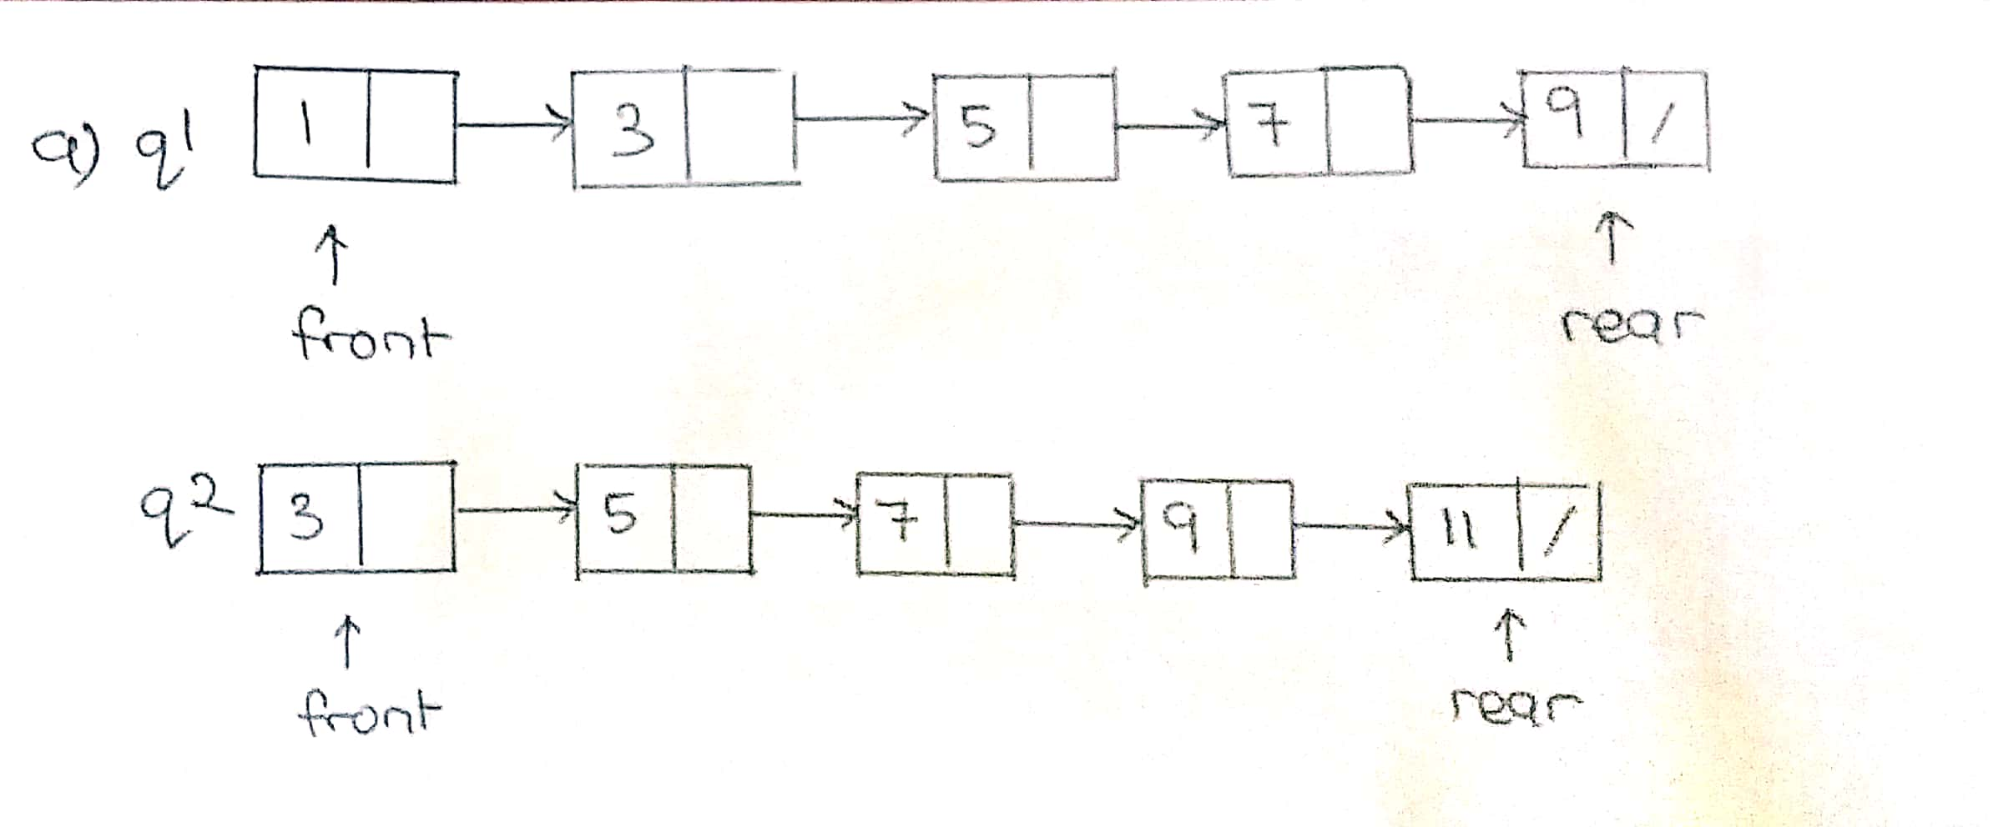

**b)** while(!q1.isEmpty()){

data=q1.dequeue();

q3.enqueue(data);

}

while(!q2.isEmpty()){

data2=q2.dequeue();

q3.enqueue(data2);

}

**2. Dec 2018**

**Question 5**

**a)** 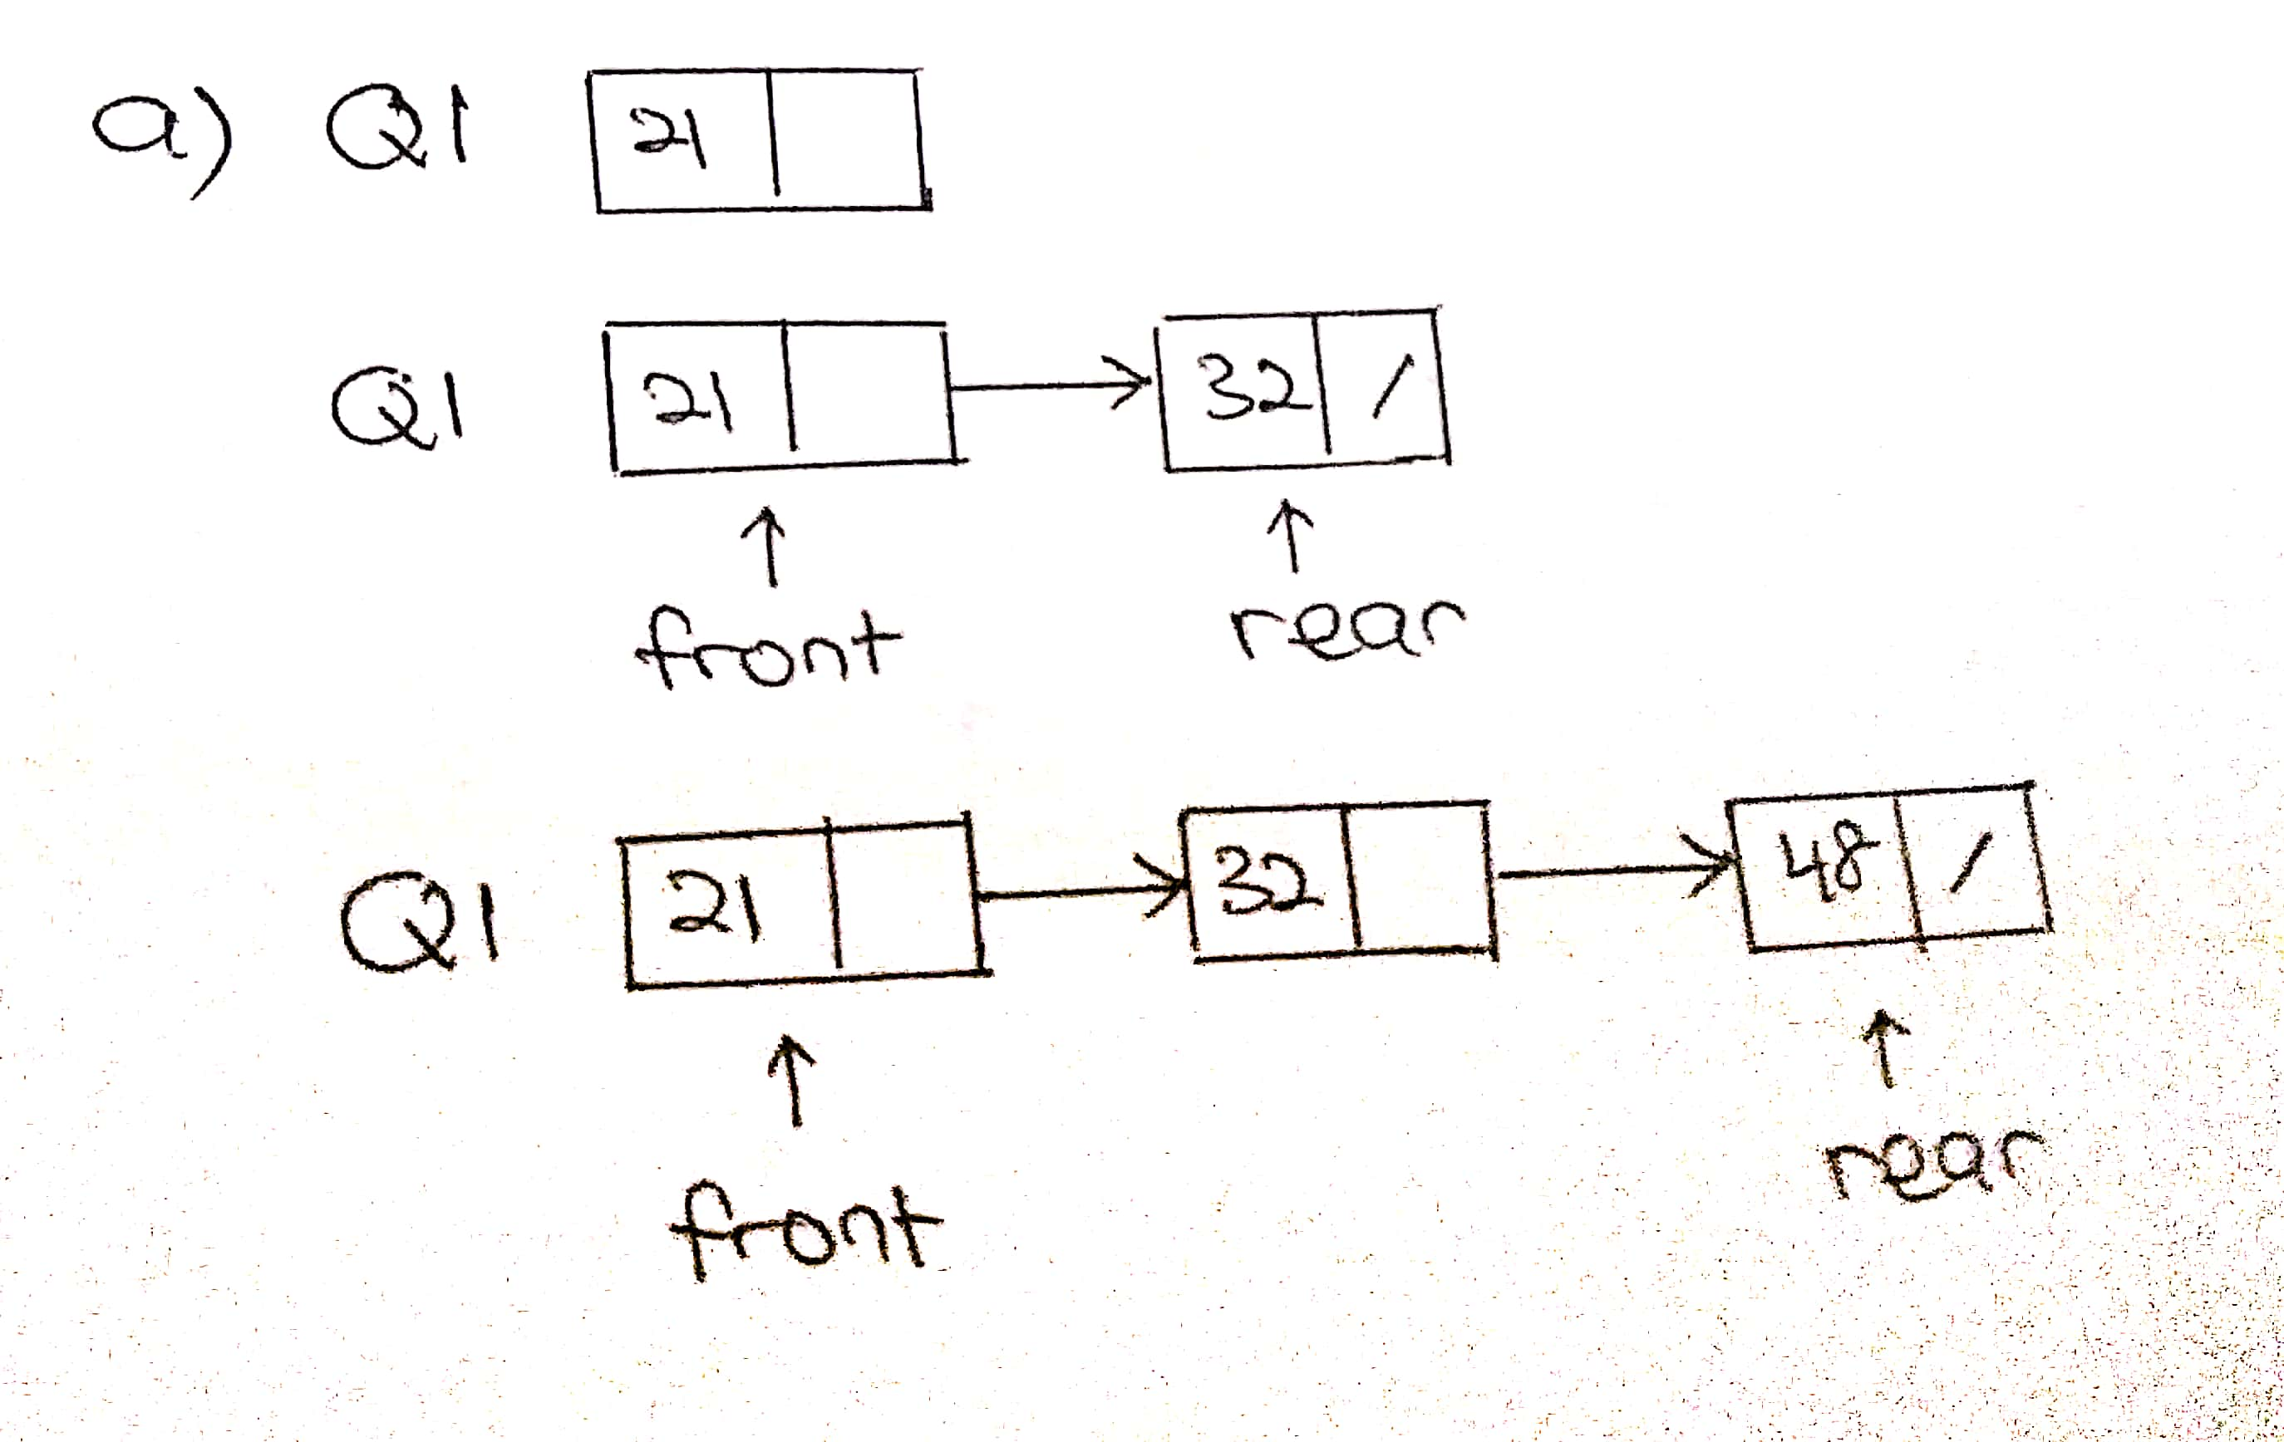

**b)** Queue highCc = new Queue();

Queue lowCc = new Queue();

while(!myQ.isEmpty()){

C = (CarModel)myQ.dequeue();

if(C.getCubicCapacity() <= 1300){

lowCc.enqueue(C);

}

else {

highCc.enqueue(C);

}

}

**3. Jan 2018**

**Question 5**

**a)** Queue tempQ = new Queue();

int countL=0;

while(!lorryQueue.isEmpty()){

Lorry L = (Lorry)lorryQueue.dequeue();

if(L.getDateReg().substring(5,9).equalsIgnoreCase("2016")){

countL++;

}

System.out.println("Number of lorries registered in 2016: " + countL);

tempQ.enqueue(L);

}

**b)** Stack phgStack = new Stack();

while(!tempQ.isEmpty()){

Lorry L = (Lorry)tempQ.dequeue();

if(L.getState().equalsIgnoreCase("Pahang")){

//Stack phgStack = new Stack();

phgStack.push(L);

}

else{

lorryQueue.enqueue(L);

}

}